Group Name: The Darkest Error

Group Members: Thomas Citrowske

Frankie Mccaa

Anthony Pardo

Nathan Pimentel

Dakota Stephens

Mindy Zheng

User Manual

Table of Contents

1. First Page

2. Filling out the Form

3. Running the Experiment

4. Showing the Graph

5. Graph Screen

1. First Page

When the user first enters the website they should see two buttons at the top. The first button (Run Experiment) should be pressed after filling out the form on the rest of the page. The second button (Fill Random Experiment) can be pressed to fill the form out to run the experiment with random values. Clicking the *Usage* button at the top left of the navbar will show how to use the website.

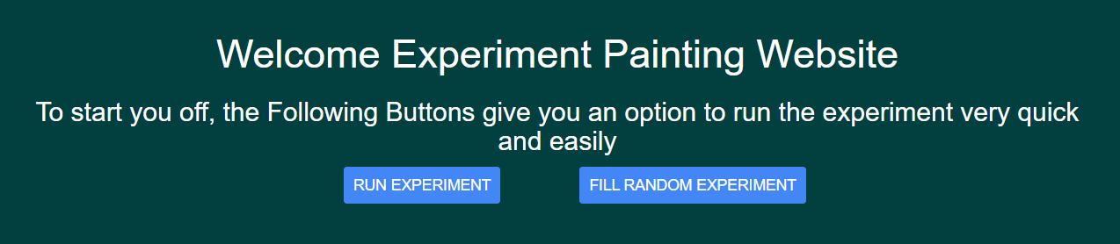

2. Filling out the Form

If the user doesn’t want random values, they must fill out the form to run the experiment with their chosen variable values. To fill out the form, first select a variable for the independent variable. Then input at least 4 values into the list in the middle of the form. To fill the list, the user must input a number in the field below the list and press the *Add Number* button. Then after filling this list with independent variable values, the list for dependent variable values will appear to the right. This field must be filled out also.

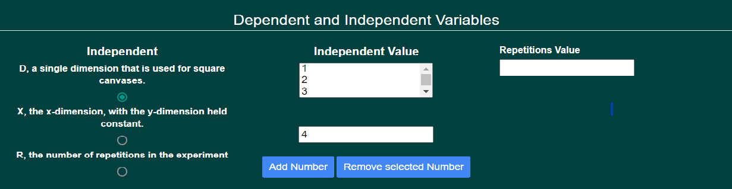

3. Running the Experiment

After filling those fields, the colors, stopping criteria, and song choice can be filled out below. When all fields are filled out, the user should press the *Run Experiment* button. The next screen will be the running experiment. During the run of the experiment the speed can be sped-up or slowed down u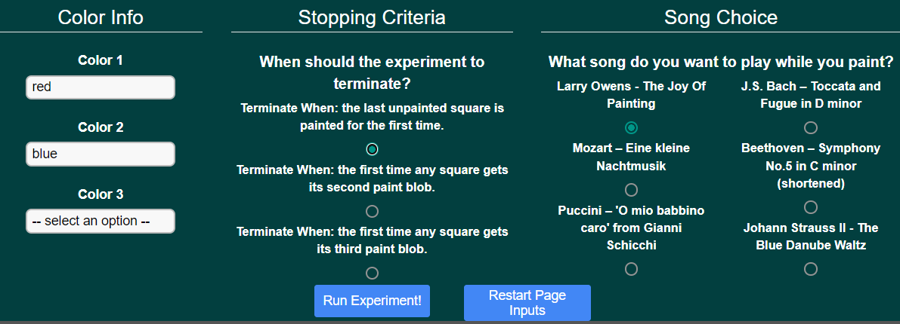sing the slider control on the left.

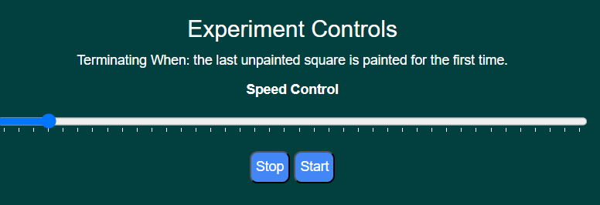

4. Showing the Graph

After the experiment is finished the variable to be calculated is shown at the bottom. The user should choose one of these variables to calculate and be shown on the graph. After choosing this variable the user should press the *Continue* button which will display a graph.

5. Graph Screen

Once on the graph screen the user can select buttons to either: *Make a new table/graph, Abandon this experiment, or Quit the program.*

**